MPA 634  
Data Science for Managers  
Midterm I: Winter 2019

# I. Definitions and Concepts

1. Define standardized variables, covariance, and correlation. Explain how they are related to each other.  
     
   standardized variables  
     
     
     
     
   covariance  
     
     
     
     
   correlation  
     
     
     
     
   relationship
2. Carefully explain how the whiskers of a boxplot are constructed. How do whiskers help us identify outliers?
3. Define each of the three parts of exploratory data analysis.  
   1. Transformation
   2. Visualization
   3. Modeling
4. Explain how geoms and stats are related to each other in the layered grammar of graphics. Illustrate your answer with an example.
5. **Compare** the location, scale, symmetry, and outliers of city and highway mileage using the following information:

# A tibble: 2 x 5

type_of_driving Mean Median Standard_Deviation Interquartile_Range

*<chr>* *<dbl>* *<dbl>* *<dbl>* *<dbl>*

1 cty 16.9 17 4.26 5

2 hwy 23.4 24 5.95 9

* 1. Location
  2. Scale
  3. Symmetry
  4. Outliers

# II. Line by Line Code Interpretation

Code Chunk 1 (Don’t worry about the labeling code)

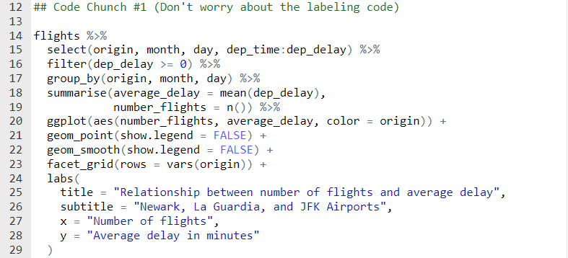

Code Chunk II (Don’t worry about the labeling code)

